Institute of Computer Technology

B. Tech Computer Science and Engineering

Subject: Basics Of Communication Systems (2CSE202)

**PRACTICAL-1**

**AIM: - To learn Switch and Hub Network**

**Q/A: -**

**1. What is cisco packet tracer?**

**ANS:** It is a tool to track the packets/information which is transferred into end-to-end systems.

**2. Why do we use simulator?**

**ANS:** We generally use simulators because they are time saving, cheap, can provide user required environment, can give analysis of the work and it is safe rather than doing experiments in real life.

**3. Then what is cisco packet simulator?**

**ANS:** Cisco packet simulator is a tool that simulates the environment to provide us for making communication systems and provides analytics preview of the system and let the user design many network systems.

**4. How does it work?**

**ANS:** It works as a simulation and provides a base for users to design complex networking systems and give analytic results.

**5. Why do we need to use it?**

**ANS:** We use it because it is reliable, easy to use, has many functions, it is cost-free, it is harmless, it is safe for us for experimenting various network systems.

**6. What is a ping command and what is use of it?**

**ANS:** PINGcommand is basically used to check the connectivity between two or more systems.

**7. What is the main differences between switch and hub?**

**ANS:** Both switch and hub are connection devices. Major difference between hub and switch is that hub sends the packet to all the devices connected to it and switch only sends the packet where it is to deliver.

***PING TEST:***

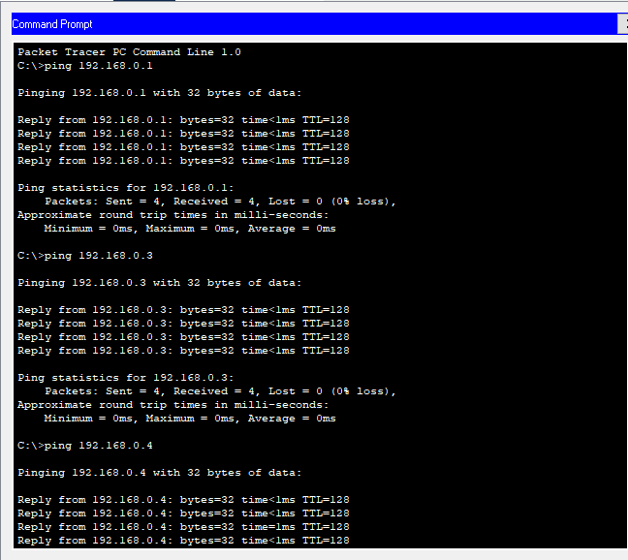

***Switch Network:***

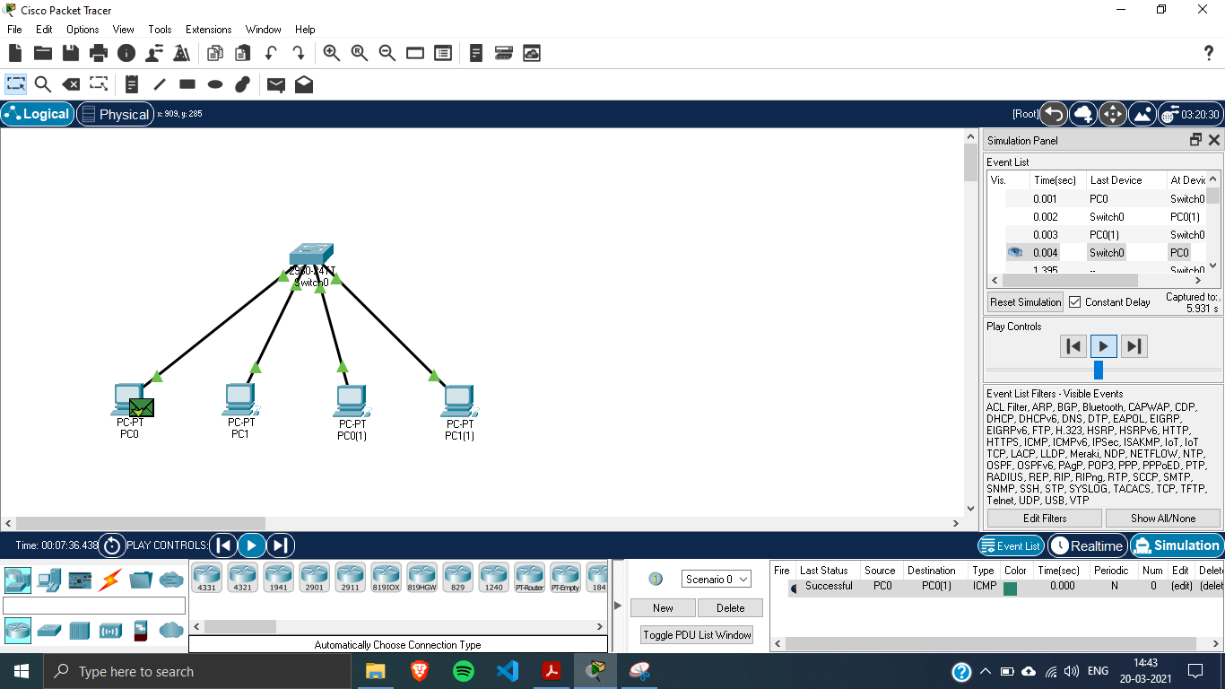

***Hub Network:***

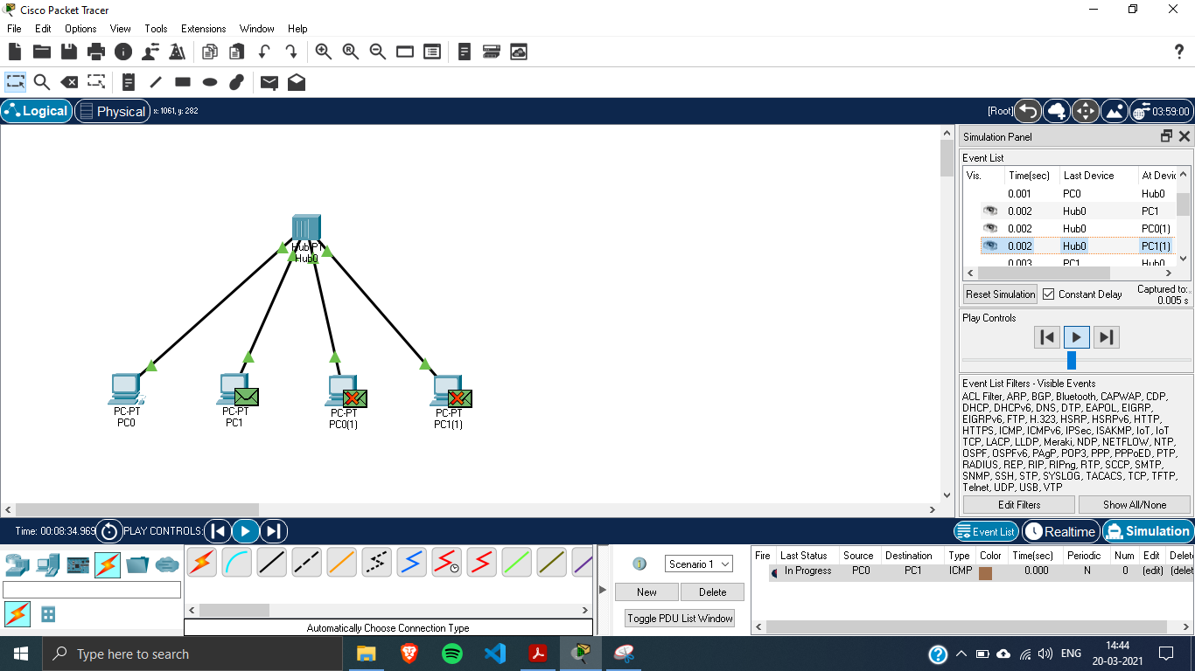

***Switch and Hub (Hybrid) Network:***

